**Methods Test 8 2018**

**Calculus**

**Time Allowed: 60 minutes Total Marks: 60**

**Name: _______________________**

**SECTION A – Resource Free 25 minutes – 24 marks**

**ALL** working must be shown for full marks.

**1.** **[1, 1, 2, 2 = 6 marks]**

Find the anti-derivative of each of the following

a) 3x - 5 b) 4 - x² + 3x³

c) $\frac{4x^{3}-1}{3}$ d) $\frac{{5x}^{3}-x^{4}}{2x^{2}}$

**2.** **[1, 2, 2 = 5 marks]**

Find each of the following:

a) $\int{5x dx}$ b) $\int{2{(2x-1)}^{2}} dx$

c) $\int{x(x^{2}}-2x^{3}$ +1) dx

**3.** **[2, 2 = 4 marks]**

Given the gradient function and a point of the curve, find the equation of each of the following curves:

a) Gradient function $\frac{dy}{dx}= -2$, point on the curve (1, -3)

b) Gradient function y’ = $3x^{2}-16x+5$, point on the curve (1, 2)

**4.** **[4, 2, 3 = 9 marks]**

The gradient function for a particular curve is given by $\frac{dy}{dx}= -3x^{2}+12x-9$.

a) At some point A on this curve the equation of the tangent line is given by y = 32 – 9x. Find the coordinates of the point A given that the abscissa of A is positive.

b) Find the equation of this curve.

c) Find the equation of a tangent line which is parallel to the given tangent line

y = 32 – 9x.

**Methods Test 8 2018**

**Calculus**

**Time Allowed: 60 minutes Total Marks: 60**

**Name: _______________________**

**SECTION B – Calculators** **Allowed**  **35 minutes 36 marks**

**5.** **[6 marks]**

Sketch the graph of a function satisfying all of the following conditions:

* f(x) = 0 at x = -2 and x = 3
* f’(x) < 0 for x < 0
* f’(x) = 0 at x = 0 and x = 4
* f’(x) > 0 for 0 < x < 4 and x > 4

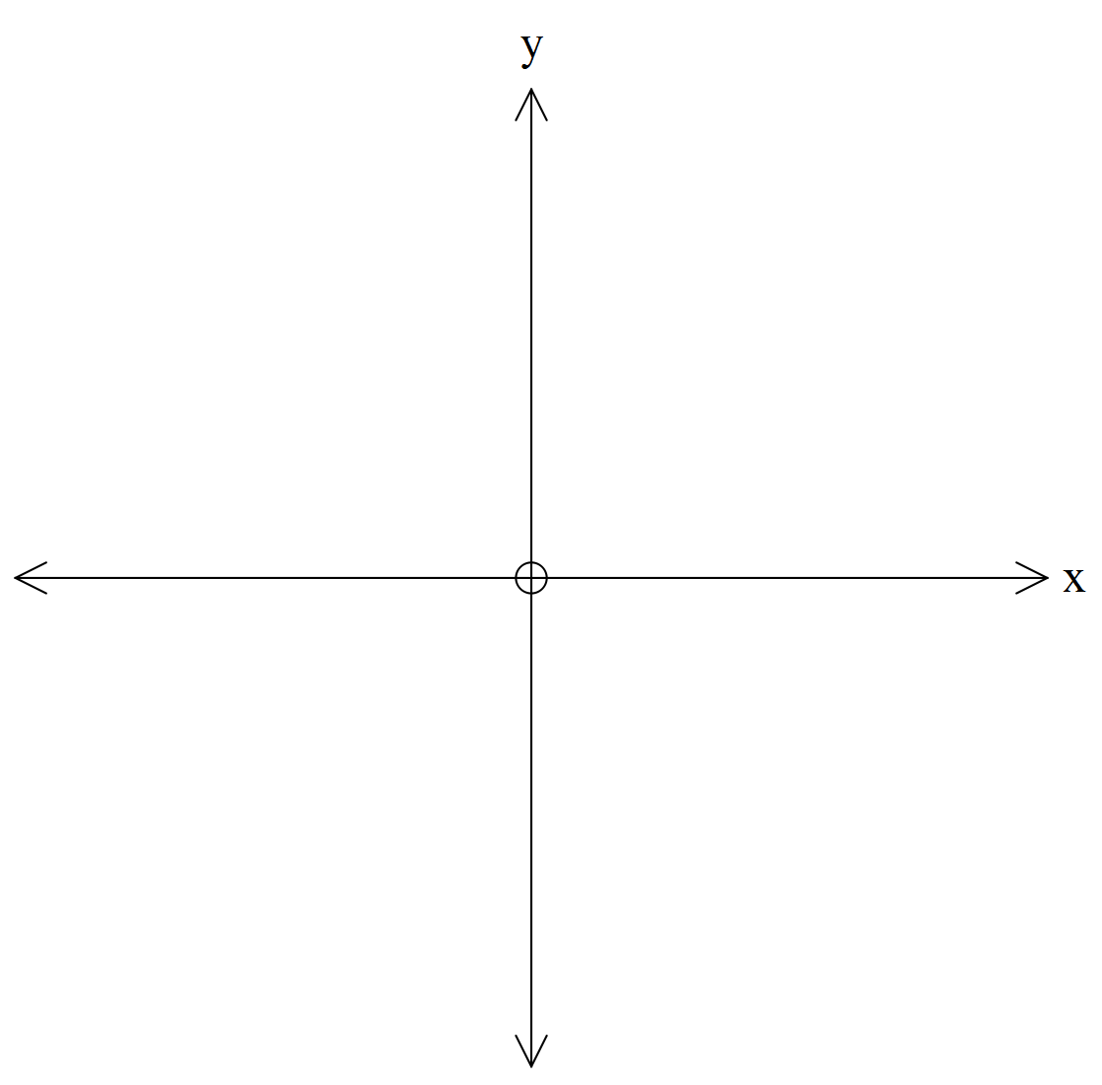

**6.** **[1, 1, 2, 2, 2, 2, 4 = 14 marks]**

The quantity Q (in mg) of a particular drug in the blood stream of a person at a time t (in hours) can be modelled by the polynomial equation: $Q=0.01t^{3}-t^{2}-t+100 for t ≤10.$

a) What quantity of the drug is present in the blood stream initially?

b) What quantity of the drug is present in the blood stream after eight hours?

c) Find the average rate of decrease of the quantity of this drug in the blood stream during the first 8 hours.

d) Determine the rate of decrease of Q at any time t.

e) Find the rate of change of the quantity of the drug in the blood stream at t = 8.

f) Comment on the different rates of decrease found in c) and e) above.

g) Find Q the quantity of the drug in the blood stream when the instantaneous rate of decrease is 10.25 mg per hour.

**7.** **[1, 1, 6 = 8 marks]**

Miss Bennett is organizing the Year 12 Awards Night. She believes that if the tickets are priced at $80 each she will be able to sell 500 tickets. For each $5 increase in the price of each ticket, she expects the sales to decrease by 10 tickets.

a) Find the number of tickets she expects to sell if the price of each ticket is increased by x lots of $5.

b) Find the expected revenue when the price for each ticket is raised by x lots of $5.

c) Use calculus to find the price per ticket that will maximize the revenue. State the maximum revenue.

**8.** **[4, 4 = 8 marks]**

A rectangular box with a square base is to be made with a volume of 1500cm3.

Let cm be the length of each side of the square base and cm be the height of the box as shown in the diagram.



a) **Show** that the formula for the surface area is



b**) Use calculus** to determine the value of , correct to 1 decimal place, that will minimise the surface area.